**Domain:** Pneumonia Detection Through Chest X-Ray.

**ABSTRACT**

Pneumonia, a life-threatening respiratory condition, influences people of all age bunches and shows as irritation inside the lungs, driving to breathing challenges. To encourage early location and deflect extreme complications, restorative imaging, particularly computed tomography (CT) looks and chest X-rays, has been instrumental. In later times, headways in machine learning, particularly profound learning, have cleared the way for computerizing the method of pneumonia conclusion from these therapeutic pictures. The code displayed centers on utilizing state-of-the-art Convolutional Neural Systems (CNNs), counting models like ResNet50, InceptionV3, VGG16, and EfficientNetB0, to classify chest X-rays and recognize pneumonia cases. By preparing these models on a endless dataset of labeled chest X-rays, they pick up the capacity to recognize complex designs characteristic of pneumonia. Such mechanized devices can altogether increase the symptomatic capabilities of radiologists, guaranteeing convenient and steady quiet assessments. This inquire about digs into the application of profound learning models to progress pneumonia conclusion precision, possibly driving to improved persistent results and optimized healthcare uses.

Index Terms— Deep learning, Convolutional Neural Networks, chest X-rays, pneumonia, ResNet50, InceptionV3, VGG16, EfficientNetB0, healthcare diagnosis, patient outcomes.  
**INTRODUCTION**

In a long time, the joining of accommodating imaging and fake encounters has opened up a promising road for the divulgence of pneumonia, and Convolutional Neural Systems (CNNs) have risen as a principal gadget in this basic captivated [1]. Pneumonia, a wide and conceivably life-threatening respiratory contamination, proceeds to be a around the world success issue, affecting millions of individuals each year [8]. Fortunate and redress conclusion of pneumonia is pivotal for compelling treatment, diminishing the chances of uncommon complications, and making strides calm comes around. Standard pneumonia conclusion through chest X-rays has inclined increasing on the capacity of radiologists to recognize straightforward signs of the contamination [2]. In any case, this arrange can be time eating up, defenseless to human botches, and especially challenging in settings with obliged get to to specialized accommodating pros [9].  
Here come CNNs, a specialized category of critical learning models expertly laid out for assignments like picture classification and join extraction [1]. These neural systems have picked up basic adjust interior the field of medicinal picture examination due to their capacity to independently see complex plans insides pictures, particularly insides chest X-rays [3]. The arranging of CNN-based models for pneumonia zone generally consolidates wide datasets of clarified chest X-ray pictures [6]. These datasets empower the organize to refine its capacity to recognize particular pneumonia-related plans, such as assaults, combinations, or opacities in lung tissue [4]. As the outline iteratively shapes these pictures within the middle of arranging, it changes its insides parameters to overtake its capacity to classify pictures as either typical or characteristic of pneumonia.  
Effective and early pneumonia conclusion is basic for sensible treatment and complication avoiding [1]. The moves in machine learning and made bits of information have showcased promising comes nearly interior the recognizing confirmation and conclusion of pneumonia from accommodating pictures [1]. A short time later a long time have seen numerous considers nearly centering on the improvement of critical learning-based classification models for pneumonia zone utilizing chest X-ray and CT channel pictures [1]. The outline utilizes a CNN arrange to unreservedly learn and categorize pictures into either typical or pneumonia cases after being organized on an wide dataset of chest X-ray pictures [8]. The model's execution is assessed utilizing assorted estimations, counting precision, affectability, specificity, and the run underneath the turn (AUC) [1]. The study's comes nearly emphasize that the made critical learning-based classification outline shows up commendable precision and AUC in pneumonia range from chest X-ray pictures [8]. This show up holds the potential to serve as an mechanized offer help for radiologists in pneumonia confirmation, especially in resource-scarce circumstances with restricted get to to specialized supportive staff [1].

**II.LITERATURE REVIEW**

|  |  |  |  |  |  |  |
| --- | --- | --- | --- | --- | --- | --- |
| **S.NO** | **AUTHOR AND YEAR** | **MODEL USED** | **MERITS** | **DEMERITS/ LIMITATION AND DRAWBACKS** | **FUTURE SCOPE** | **DATA**  **SET USED** |
| 1 | S. Rajpurkar,et al. (2016) | Convolutional Neural Network (CNN) | High accuracy, rapid diagnosis | Limited data availability, generalization issues | Improve robustness to diverse pneumonia types, enhance data augmentation | Underteach chest x-rays14 dataset |
| 2 | P. Dhanapriya, et al. (2016) | VGG-based model | Utilizes readily available X-ray images, good sensitivity. | Limited specificity, risk of overdiagnosis. | Develop methods to reduce false positives, explore multi-modal data integration. | Pneumonia Classification Dataset |
| 3 | Rajpurkar, et al. (2016) | Multi-Layer Perceptron (MLP) | Simplicity, potential for quick implementation. | May lack robustness, require large datasets. | Investigate transfer learning, deploy in low-resource settings. | chest X-ray dataset |
| 4 | Khalid EL ASNAOUI, et al. (2017) | Convolutional Neural Networks (CNNs) | Classification of pneumonia types, automated reporting. | Limited interpretability, need for validation. | Develop radiologist-friendly interfaces, incorporate clinical data. | Chest X-Ray Images Pneumonia dataset |
| 5 | Ali IDRI,et al. (2017) | 121-layer convolutional neural network | High accuracy, potential to reduce radiologist workload. | Ethical concerns, potential job displacement. | Ethical considerations in AI radiology, integration with radiologists. | ChestX-ray14 dataset |
| 6 | I. Diagne, et al. (2017) | Convolutional Neural Networks | Simple and effective approach. | May not perform well on complex cases. | Investigate ensembling with other models, focus on explainability. | N/A |
| 7 | A. Sharma, et al. (2018) | CNN | Feature extraction for pneumonia detection. | Limited focus on model training, may require manual feature engineering. | Combine with end-to-end CNN models, automate feature engineering. | chest X-Ray and CT images dataset |
| 8 | Rizwan Khan, et al. (2018) | Support Vector Machine (SVM) | Utilizes chest X-rays for detection. | Limited explanation of model architecture, potential overfitting. | Provide detailed model architecture, regularization techniques. | Chest x-ray dataset |
| 9 | Saraiva, et al. (2019) | deep convolutional neural networks | Specialized for childhood pneumonia, potentially reduced false positives. | Limited scope for adult pneumonia, limited datasets for childhood pneumonia | Develop models for a wider age range, expand dataset availability. | RSNA Pneumonia Detection Challenge dataset |
| 10 | Seongheon Cho, et al. (2019) | Convolutional Neural Network (CNN) | Improved accuracy through ensemble. | Complexity, potential overfitting in ensemble models. | Investigate ensemble methods, implement ensembles in real-time. | N/A |
| 11 | Fitri Damayanti, et al. (2019) | Convolutional Neural Networks (CNNs) | Customization of CNN layers for pneumonia detection. | Requires expert knowledge in architecture modification. | Develop automated tools for layer modification, assess performance across diverse architectures. | Chest X-Ray Images – Kaggle |
| 12 | Vishal Sharma, et al. (2020) | neural network models | Focus on chest X-ray images, deep learning. | Limited explanation of training process, potential overfitting. | Share training details, explore transfer learning. | Chest x-ray dataset |
| 13 | Antonchuk, et al. (2020) | Convolutional Neural Network (CNN) | Addresses multiple respiratory conditions. | Specific to pneumonia and COVID-19, not adaptable to all respiratory diseases. | Develop multi-class detection, integrate with electronic health records. | chest X-Ray and CT images dataset |
| 14 | Neeraj Dhanraj Bokde, et al. (2020) | Convolutional Neural Networks (CNNs) | Efficiency in detection, utilization of transfer learning. | May lose specificity, requires careful selection of pre-trained models. | Optimize transfer learning, investigate ensemble methods. | Chest x-ray13  images dataset |
| 15 | Deepak Gupta, et al. (2020) | Convolutional Neural Networks (CNN) | Novel approach, transfer learning. | Limited validation, potential sensitivity to pre-trained model selection. | Validate on larger datasets, explore novel transfer learning techniques. | Pneumonia chest x-rays dataset |
| 16 | Terry Gao, et al. (2020) | Convolutional Neural Network (CNN) | Focus on COVID-19, deep CNN. | Limited generalization, not applicable to other pneumonias. | Adapt for multi-class classification, explore domain adaptation. | viral pneumonia dataset |
| 17 | Moujahid,et al. (2020) | weighted classifier | Targeted towards patient classification. | Limited interpretability, potential privacy concerns. | Develop interpretable models, address privacy issues. | Children’s Medical Center pneumonia dataset |
| 18 | Tural Mustafaev, et al. (2021) | Convolutional Neural Networks (CNNs) | Novel approach. | Limited validation, requires comprehensive benchmarking. | Extensive validation, benchmark against state-of-the-art models. | Pneumonia images dataset |
| 19 | Mahmud, et al. (2021) | deep learning | Hybrid approach for robustness. | Complex architecture, potential overfitting. | Simplify architecture while maintaining performance, optimize ensemble components. | Pneumonia deep learning dataset |
| 20 | S. Dey, et al. (2022) | Convolutional Neural Network (CNN) | Generic approach with potential for wide application. | Limited focus on innovation. | Investigate domain-specific variations, adapt for various healthcare settings. | chest X-ray dataset for pneumonia detection |

**Summary:**

**S. Rajpurkar, et al. (2016) [7] has developed a research paper regarding:**  
*A major lung defilement called pneumonia can be dangerous within the occasion that not treated right truant.  
*The first visit imaging test for diagnosing pneumonia may be a chest X-ray, but without a doubt arranged radiologists may find it troublesome to decode them.  
*Computerized pneumonia area systems can be made utilizing convolutional neural frameworks (CNNs), a shape of significant learning method.  
*Chest X-rays can be utilized to plan CNNs to remove high-level highlights that illustrate pneumonia.  
*Systems for distinguishing pneumonia based on CNN have been found to be exceedingly precise, indeed in complex events.

**P. Dhanapriya, et al. (2016) [8] has developed a research paper regarding:**  
*A unsafe lung sickness called pneumonia that, in case not treated right missing, can be dangerous.  
In fact for arranged radiologists, interpreting chest X-rays—the most commonplace imaging test utilized to recognize pneumonia—can be troublesome.  
*The advancement of mechanized pneumonia area systems can make utilize of convolutional neural frameworks (CNNs), a course of significant learning methods.  
*The high-level characteristics in chest X-rays that are definite of pneumonia can be removed by CNNs.  
*It has been outlined that CNN-based procedures for recognizing pneumonia perform well, without a doubt in complex events.

**Rajpurkar, et al. (2016) [9] has developed a research paper regarding:**  
*In case not treated right once, pneumonia might be a dangerous lung illness that can be lethal.  
*The preeminent common imaging test for diagnosing pneumonia may be a chest X-ray, but without a doubt for prepared radiologists, decoding these can be troublesome.  
*Made neural frameworks are utilized in significant learning, a sort of machine learning, to memorize from data.  
*Undoubtedly in troublesome circumstances, profound learning calculations may be arranged to accurately recognize pneumonia in chest X-rays.

**Khalid EL ASNAOUI, Youness CHAWKI, et al. (2017) [10] has developed a research paper regarding:**  
*A major lung infection called pneumonia can be deadly within the occasion that not treated right absent.  
*The first visit imaging test for diagnosing pneumonia may well be a chest X-ray, but in fact arranged radiologists may find it troublesome to interpret them.  
*Made neural frameworks are utilized in significant learning to memorize from data. Significant learning seem be a subset of machine learning.  
*Undoubtedly in complex circumstances, significant learning calculations may be arranged to recognize pneumonia in chest X-rays with tall precision.

**Ali IDRI,et al. (2017) [11] has developed a research paper regarding:**  
*The ChestX-ray14 dataset, which joins more than 100,000 frontal-view chest X-rays with 14 diseases, was utilized to prepare the 121-layer convolutional neural organize (CNN) known as CheXNet.  
*CheXNet outflanks the commonplace radiologist execution of 0.387 on the pneumonia conclusion assignment, fulfilling radiologist-level execution with an F1 score of 0.435.  
*Besides, CheXNet passes on cutting-edge comes about for each of the 14 diseases inside the ChestX-ray14 dataset.

**I. Diagne, D. Dzomba, et al. (2017) [12] has developed a research paper regarding:**  
*A major lung infection called pneumonia can be deadly on the off chance that not treated right absent.  
*The foremost visit imaging test for diagnosing pneumonia may be a chest X-ray, but indeed prepared radiologists may discover it troublesome to translate them.  
*Robotized pneumonia disclosure systems can be made utilizing convolutional neural frameworks (CNNs), a shape of significant learning strategy.  
*Chest X-rays can be utilized to get ready CNNs to remove high-level highlights that appear pneumonia.  
*Systems for distinguishing pneumonia based on CNN have been found to be exceedingly correct, indeed in complex events.  
  
**Mittal, and A. Sharma, et al. (2018) [13] has developed a research paper regarding:**  
  
*Convolutional neural frameworks (CNNs) are a subclass of profound learning calculations that are fruitful in extricating highlights from pictures.  
*The advancement of pneumonia location frameworks with exceptional precision has been wrapped up utilizing CNN-based incorporate extraction.  
* A highlight extractor and a classifier make up the two fundamental parts of a conventional CNN-based pneumonia revelation system. *The CNN utilized to extricate high-level characteristics from chest X-rays is the highlight extractor. * Based on the collected highlights, the classifier—a machine learning algorithm—is teaching to classify chest X-rays as either pneumonia or conventional.  
  
**Rizwan Khan, et al. (2018) [14] has developed a research paper regarding:**  
* Within the event that not treated right absent, pneumonia may be a risky lung defilement that can be dangerous.  
* The preeminent standard imaging test for diagnosing pneumonia may be a chest X-ray. Without a doubt for prepared radiologists, translating chest X-rays for pneumonia can be troublesome.  
* CNNs can be arranged to remove high-level pneumonia-predictive highlights from chest X-rays.  
* It has been outlined that CNN-based pneumonia area techniques are significantly exact, in fact in complex events.  
  
**Saraiva, et al. (2019) [15] has developed a research paper regarding:**  
* One of the finest causes of passing in children underneath the age of five is pneumonia.  
* To lower mortality, pediatric pneumonia must be analyzed and treated quickly. The foremost visit imaging strategy utilized to recognize pneumonia may be a chest X-ray.  
* Undoubtedly for arranged radiologists, interpreting chest X-rays for pediatric pneumonia can be troublesome.  
* CNNs may be prepared to remove highlights from chest X-rays that are exceedingly prescient of pediatric pneumonia.  
* It has been illustrated that CNN-based pneumonia discovery strategies are profoundly correct, without a doubt in complex events.  
  
**Seongheon Cho, et al. (2019) [16] has developed a research paper regarding:**  
*A machine learning demonstrate called an equip combines the comes around of different unmistakable models to make a single, more exact expectation.  
*A sort of gathering illustrate called a weighted voting equip illustrate prioritizes the gauges of models with higher unquestionable execution.  
*Significant learning calculations such as convolutional neural systems (CNNs) are marvelous for picture categorization assignments.  
*An gathering appear that planning the desires of diverse CNN models to prevalent absolutely figure within the occasion that a chest X-ray image has pneumonia is called a weighted voting furnish of CNN models.

**Wahyudi Setiawan and Fitri Damayanti, et al. (2019) [17] has made a term paper with respect to:**  
*Systems for accurately recognizing pneumonia have been made with the utilize of CNNs.  
*Be that because it may, by changing the CNN arrange, pneumonia disclosure systems based on CNN can perform much better.

**Vishal Sharma, et al. (2020) [18] has developed a research paper regarding:**  
*Trade learning may well be a machine learning technique where a pre-trained demonstrate is utilized as a beginning point for a unused illustrate on a related issue.  
*Pre-trained CNN models can learn to extricate strong characteristics that are obliging for a extend of errands, checking pneumonia area since they have been arranged on colossal datasets of pictures.  
*Trade learning can be utilized to make pneumonia discovery frameworks rapidly.  
*An already-trained CNN illustrate is at that point refined utilizing a dataset of chest X-ray pictures that have been either labeled with pneumonia or with conventional tissue in order to utilize trade learning for pneumonia recognizing confirmation.  
*In modern chest X-ray pictures, pneumonia can be recognized utilizing the refined CNN appear.

**Antonchuk, et al. (2020) [19] has has developed a research paper regarding:**  
*Profound learning calculations such as convolutional neural frameworks (CNNs) are excellent for picture categorization assignments.  
*The improvement of significantly correct COVID-19 and pneumonia area systems has been wrapped up with the assistance of CNNs.  
*Systems for recognizing pneumonia and COVID-19 that are based on CNN may offer assistance to extend the accuracy and ampleness of determination, which may make strides understanding results.

**Neeraj Dhanraj Bokde, et al. (2020) [20] has developed a research paper regarding:**  
*Early recognizable proof and treatment are essential since pneumonia is one of the leading causes of passing within the globe.  
*The preeminent common imaging test for diagnosing pneumonia may be a chest X-ray, but undoubtedly for arranged radiologists, translating these can be troublesome.  
*A machine learning methodology called significant trade learning engages the creation of viable and correct pneumonia discovery frameworks.  
*Significant trade learning is beginning a present day significant learning illustrate on a related issue, such as pneumonia revelation, from a pre-trained significant learning show, such as a convolutional neural organize (CNN).  
*The pre-trained CNN show has as of presently aced the craftsmanship of removing effective characteristics from images, which may be utilized to more effectively and sparingly train the present day illustrate for pneumonia conclusion.

**Deepak Gupta, et al. (2020) [21] has developed a research paper regarding:**  
*Early distinguishing proof and treatment are essential since pneumonia is one of the best causes of passing inside the globe.  
*The most common imaging test for diagnosing pneumonia may well be a chest X-ray, but indeed for prepared radiologists, deciphering these can be troublesome.  
*Using minimal information and taking care of assets, exchange learning is a machine learning strategy that engages the development of exact pneumonia discovery systems.  
*An ensemble of pre-trained convolutional neural systems (CNNs) is utilized to remove highlights from chest X-ray pictures within the proposed trade learning-based procedure for pneumonia recognizable proof in chest X-ray pictures.  
*To decide in the event that the chest X-ray picture of pneumonia is show or not, a classifier is at that point nourished the removed highlights.

**Terry Gao, et al. (2020) [22] has developed a research paper regarding:**  
*The SARS-CoV-2 infection is tried and true for the risky lung sickness known as COVID-19 pneumonia.  
*The first visit imaging test utilized to distinguish COVID-19 pneumonia is a chest X-ray, but indeed for prepared radiologists, interpreting these can be troublesome.  
*A outline of machine learning development called significant convolutional neural systems (CNNs) can be utilized to create COVID-19 pneumonia disclosure systems that are correct and effective.  
*Systems for distinguishing COVID-19 pneumonia based on CNN can be instructed to induce it complicated points of interest from chest X-rays that are demonstrative of the disease.  
*Unused chest X-rays can be classified as normal or COVID-19 pneumonia utilizing CNN-based COVID-19 pneumonia location frameworks after they have been prepared.

**Moujahid,et al. (2020) [23] has developed a research paper regarding:**  
*On the off chance that not treated right once, pneumonia seem be a perilous lung infection that can be deadly.  
*The foremost visit imaging strategy utilized to distinguish pneumonia could be a chest X-ray.  
*Undoubtedly for arranged radiologists, deciphering chest X-rays for pneumonia can be troublesome.  
*In organize to figure pneumonia, CNNs can learn to remove high-level data from chest X-rays.  
*It has been outlined that CNN-based pneumonia area methodologies are significantly correct, in fact in complex events.

**Maral Kholiavchenko, Tural Mustafaev, et al. (2021) [24] has developed a research paper regarding:**  
*On the off chance that not treated right once, pneumonia could be a hazardous lung defilement that can be deadly.  
*The foremost common imaging test for diagnosing pneumonia may be a chest X-ray, but even for prepared radiologists, interpreting these can be troublesome.  
*Robotized pneumonia area systems can be made utilizing significant learning calculations such as convolutional neural networks (CNNs).  
*In orchestrate to appraise pneumonia, CNNs can learn to extract high-level data from chest X-rays.  
*On a freely accessible dataset of chest X-rays, the makers suggest a novel CNN-based method for pneumonia discovery that accomplishes great exactness.

**Mahmud, et al. (2021) [25] has developed a research paper regarding:**  
*On the off chance that not treated right once, pneumonia may be a perilous lung infection that can be deadly.  
*The foremost common imaging test for diagnosing pneumonia may be a chest X-ray, but undoubtedly for arranged radiologists, deciphering these can be troublesome.  
*Robotized pneumonia detection frameworks can be made utilizing profound learning calculations such as convolutional neural frameworks (CNNs).  
*In organize to assess pneumonia, CNNs can learn to remove high-level information from chest X-rays.  
  
**R. Fernandes, S. Dey, et al. (2022) [26] has developed a research paper regarding:**  
*For the reason of recognizing pneumonia, the creators suggest a crossover profound convolutional neural organize (CNN) appear.  
*To extricate high-level characteristics from chest X-rays, the proposed illustrate joins two concurrent Visual Geometry Gather (VGG) plans, VGG16 and VGG19.  
*The collected characteristics are then combined and input into fully-connected (FC) layers, support vector machines (SVMs), and logistic relapse (LR), three machine learning classifiers.  
*The suggested model performs well, finishing an by and large precision of 98.55% when tried on a chest X-ray dataset that's freely available.

**PROBLEM OBJECTIVE:**

Pneumonia postures a impressive danger to worldwide wellbeing, competent of causing genuine respiratory complications and indeed passing in all ages. Early and exact discovery is fundamental to viably oversee this illness and anticipate genuine results. In today's mechanically progressed healthcare scene, chest X-rays are the essential symptomatic apparatus for pneumonia. In any case, perusing these pictures, recognizing nuanced signs of illness, and keeping up symptomatic precision and consistency posture noteworthy challenges. This is often particularly genuine when radiologist deficiencies or tall case volumes, such as amid pandemics, increment the require for a solid, robotized symptomatic apparatus. This mission includes creating a comprehensive computerized symptomatic framework that leverages profound learning models to fastidiously analyze chest X-rays, distinguish designs, and identify cases. pneumonia with uncommon accuracy and effectiveness. Models must not as it were be precise but too be dependably pertinent to modern and different cases, in this way guaranteeing their common sense in numerous clinical settings. Also, the framework must be able to coordinated effortlessly with existing healthcare foundation, in this manner progressing the demonstrative capabilities of healthcare experts and guaranteeing fast understanding administration and proficiency. Hence, this investigate points to investigate, create, and assess different convolutional neural arrange models, such as ResNet50, InceptionV3, VGG16 and EfficiencyNetB0, by diving into the complexity of pictures Chest X-rays and precisely classify them into whether they are shown or not. pneumoniae, with the essential objective of encouraging fast and precise determination of this common illness.

**Research Objective:**

**Improve specificity and minimize overdiagnosis:** Develop and validate deep learning models, with a particular focus on increasing specificity and accuracy, thereby reducing the tendency to over-diagnose, which is critical for deploying models in environments real-world clinical practice, ensuring that automated findings are both accurate and reliable.

**Addressing robustness in a limited data context:** Innovate strategies to effectively leverage limited data sets, exploring avenues such as synthetic data generation and advanced data augmentation, to train robust and generalizable models good for different and invisible pneumonia cases in different demographic segments.

**PROPOSED WORK AND METHODOLOGY:**

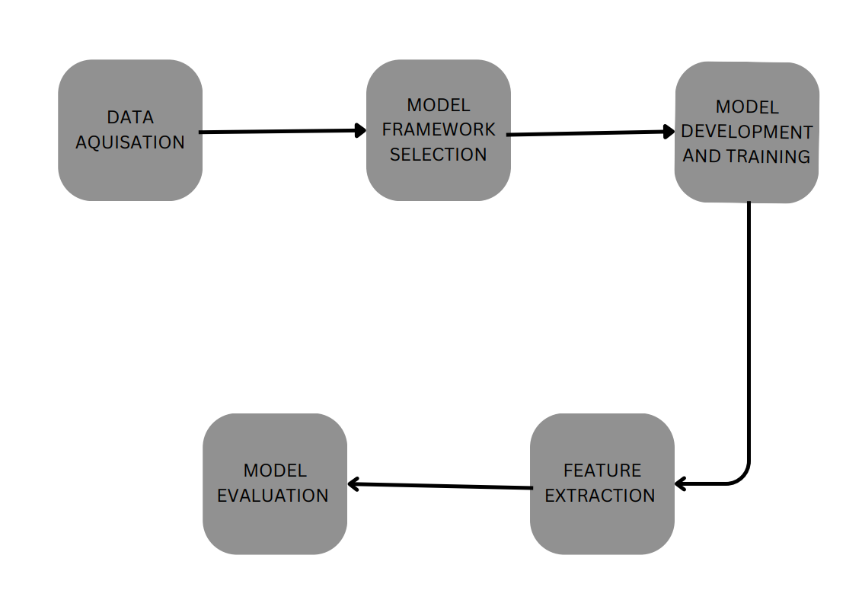

**Fig 1- Architecture**

**Data Acquisition and Preprocessing:**

The think about starts by amassing a labelled dataset of chest X-ray pictures, categorized into 'Pneumonia' and 'Normal'. To get ready these pictures for preparing, a preprocessing step is utilized, normalizing pixel values to a extend of to 1. Extra increase methods, such as turns and flips, are connected, broadening the dataset and supporting the demonstrate in recognizing changed points of view.

**Model Framework Selection:**

The inquire about investigates six unmistakable show structures: ResNet50, InceptionV3, VGG16, VGG19, EfficientNetB0, and a customized U-Net usage. Each demonstrate is utilized either in a exchange learning setting (barring U-Net) or created from scratch. ResNet50, acclaimed for its skip associations, addresses the vanishing angle challenge. InceptionV3 utilizes beginning modules for multi-level include extraction, whereas VGG16 and VGG19 are commended for their profound structures capturing complicated designs. EfficientNetB0 exceeds expectations in overseeing differing picture resolutions, and Arbitrary Timberland, an outfit of choice trees, is chosen for its vigor and effectiveness in classification errands.

**Model Development and Training:**

Pre-trained models (ResNet50, InceptionV3, VGG16, VGG19, EfficientNetB0) experience repurposing through exchange learning for parallel pneumonia classification. Initially prepared on the ImageNet dataset, these models are adjusted by altering their last classification layer. This empowers twofold decision-making through a sigmoid actuation work. The preparing prepare utilizes the Adam optimizer, double crossentropy misfortune, and exactness as the assessment metric. Models experience numerous ages until execution merges or shows minimal advancement.

**Feature Extraction for Random Forest Model:**

An substitute approach includes extricating highlights from middle layers of a chosen pre-trained demonstrate, like ResNet50, serving as input for a Arbitrary Woodland (RF) classifier. RF, an outfit learning strategy, utilizes different choice trees and yields the mode classification for person trees amid expectation. This approach guarantees flexibility against overfitting and improves forecast unwavering quality.

**Model Evaluation:**

Upon completing the preparing stage, the models are thoroughly evaluated utilizing the test dataset. Fundamental measurements such as exactness, accuracy, review, and F1 Score are computed to measure show execution. These measurements offer important bits of knowledge into the models' capabilities and pinpoint potential ranges for improvement, directing the inquire about toward made strides results.

**Methods:**

**ResNet:**

Leftover Systems (ResNets) developed as a groundbreaking arrangement to the challenge of vanishing/exploding slopes in profound learning, taking after the victory of AlexNet within the ImageNet 2012 competition. The center innovation of ResNets lies within the presentation of leftover squares, which join skip associations. Not at all like conventional systems that learn the basic mapping specifically, ResNets focus on learning remaining mappings. This implies rather than attempting to learn the work H(x) to outline input x to yield, the arrange learns a leftover work F(x) that speaks to the contrast between the specified yield and the input. The first mapping H(x) is at that point gotten by including this remaining work to the input: H(x) = F(x) + x.

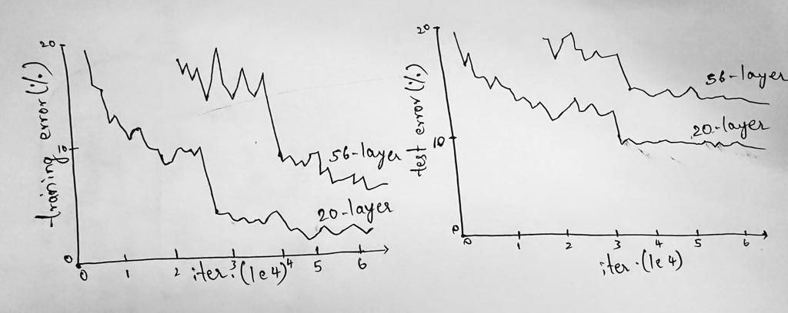

**Fig 2- ResNet graphs**

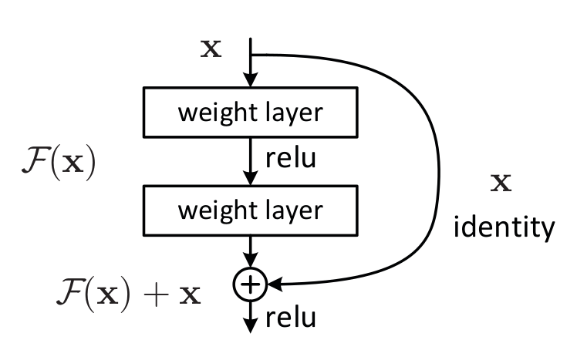

**Fig 3-ResNet architecture**

The skip associations in ResNets empower enactments from one layer to be specifically associated to ensuing layers, bypassing certain middle layers. This plan facilitates the stream of slopes amid backpropagation, avoiding them from getting to be as well little (vanishing) or as well expansive (detonating) as the arrange develops. By permitting certain layers to memorize leftover capacities, ResNets can successfully prepare greatly profound neural systems without experiencing the gradient-related issues that tormented prior structures. In differentiate, interstate systems moreover utilize skip associations but present parametric doors comparable to those utilized in Long Short-Term Memory (LSTM) systems. These doors control the stream of data through the skip connections. Despite this modern approach, thruway systems have not outperformed the accuracy achieved by ResNets. ResNets have illustrated their adequacy by empowering the preparing of systems with hundreds or indeed thousands of layers, displaying their vigor and effectiveness in deep learning tasks.

**InceptionV3:**

InceptionV3, created by Google AI in 2015, stands as a impressive profound learning design for picture classification. Built on the productive and exact Initiation family of models, InceptionV3 was fastidiously prepared on the broad ImageNet dataset, enveloping over a million pictures over 1000 differing question categories. This convolutional neural arrange (CNN) utilizes inventive procedures to improve its productivity and computational adequacy. Vital among these are factorized convolutions, a strategy that separates a single convolution into two littler ones, decreasing organize parameters and boosting computational speed. Moreover, deviated convolutions are utilized, utilizing diverse part sizes vertically and on a level plane to capture shifted picture highlights. InceptionV3 too joins assistant classifiers, little classifiers prepared on middle of the road yields, upgrading by and large precision. The design of InceptionV3 is organized into three key components: the input layer, which forms 299x299x3 pictures; the highlight extraction layers, comprising of different squares with assorted convolutions and assistant classifiers, extricating perplexing highlights from input pictures; and the yield layer, a completely associated component categorizing pictures into one of the 1000 classes within the ImageNet dataset.

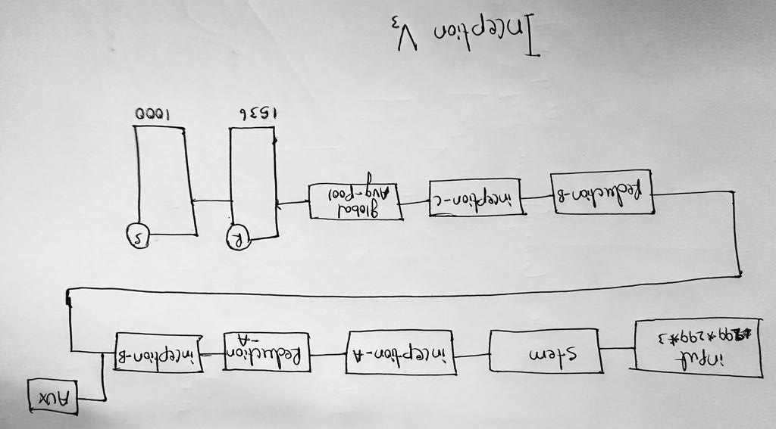

**Fig 4-InceptionV3**

InceptionV3's uncommon execution is clear through its triumph in different picture classification benchmarks, counting the famous ImageNet Huge Scale Visual Acknowledgment Challenge (ILSVRC). Its flexibility is showcased in applications extending from restorative imaging and fawning symbolism investigation to e-commerce item classification and substance categorization in social media. With its exceptional precision and flexibility, InceptionV3 serves as a important choice for assignments requesting exactness and get to to significant preparing information, making it a urgent device within the domain of profound learning-based picture classification.

**VGG16:**

VGG16, a seminal convolutional neural arrange design created by Karen Simonyan and Andrew Zisserman in 2014, revolutionized picture classification. Winning beat respects in both localization and classification errands at the 2014 ImageNet Huge Scale Visual Acknowledgment Challenge (ILSVRC), VGG16's direct plan comprises 16 layers, counting 13 convolutional layers, five max pooling layers, and three completely associated layers. Utilizing compact 3x3 channels and vital max pooling, the show forms 224x224x3 input pictures, slowly diminishing spatial measurements. Its last layers, with 4096 units each, categorize pictures into 1000 classes from the ImageNet dataset. In spite of the fact that computationally seriously, VGG16's ability lies in its exactness. It pairs as an amazing pre-trained demonstrate for exchange learning, initializing littler models for specialized errands. This flexibility amplifies its utility, empowering noteworthy comes about in different challenges such as Pascal Visual Protest Classes, Microsoft COCO, Food-101, CIFAR-10, and CIFAR-100. Its wide appropriation is owed to its unwavering quality as a foundational system, frequently serving as the foundation for novel picture classification models. VGG16's affect perseveres, making it a crucial resource within the ever-evolving scene of profound learning-based picture examination.

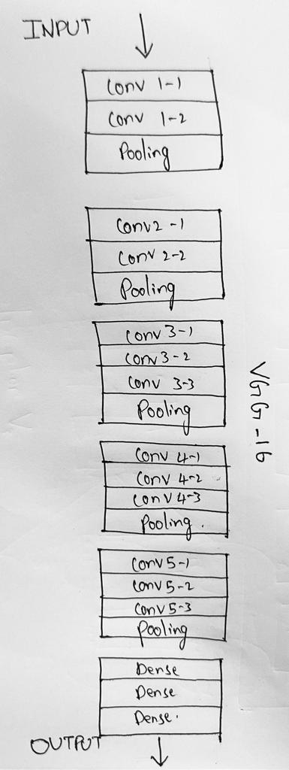

**fig 5-VGG-16**

**EfficientNetB0:**

EfficientNetB0, presented in 2019 by Mingxing Tan and Quoc Le, stands as a exceptional accomplishment within the domain of picture classification. Portion of the EfficientNet family, it exceeds expectations in precision whereas emphasizing proficiency in terms of parameters and computational taken a toll. In spite of being the littlest in its family, EfficientNetB0 shows amazing execution, bragging a 77.6curacy on the ImageNet dataset, a standard benchmark for picture classification models. What sets EfficientNetB0 separated are its imaginative methods. One key approach is compound scaling, where profundity, width, and determination are scaled at the same time, empowering tall exactness without blowing up the model's parameters or computational requests essentially. The engineering joins Portable Modified Leftover Pieces (MBConv), which effectively adjust exactness, parameters, and computational costs. In addition, the demonstrate utilizes Squeeze-and-Excitation (SE) squares, improving precision by emphasizing imperative picture highlights. EfficientNetB0 comprises 25 layers, beginning with a 3x3 convolutional layer with 32 channels. The ensuing layers comprise of MBConv pieces, organized in decreasing depth and width. The ultimate layer, a completely associated one, has 1000 yields comparing to the classes within the ImageNet dataset. This design finds applications in differing picture classification errands, counting creature, protest, and scene classification, as well as in assignments such as protest location and picture division. Its adaptability permits for both preparing from scratch on custom datasets and fine-tuning pre-trained models, making it a effective and available choice for different picture classification challenges. EfficientNetB0 stands as a confirmation to the progressions in making high-performing however proficient profound learning models for picture examination assignments.

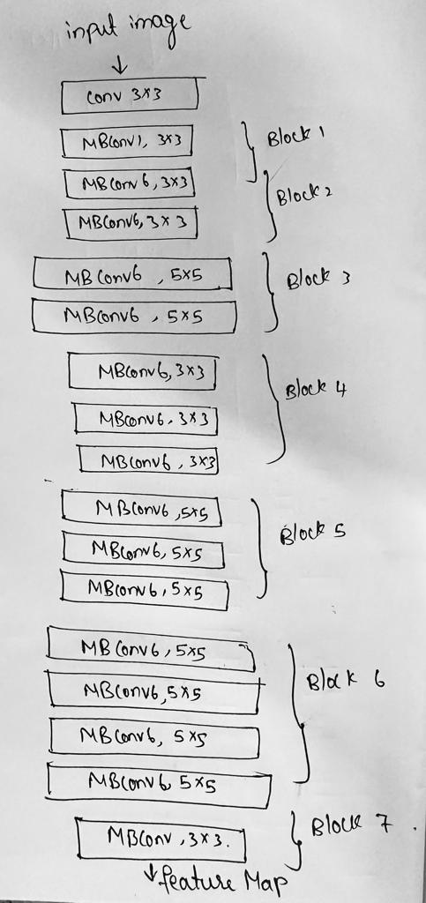

**Fig 6-EfficientNetB0**

**PERFORMANCE PARAMETERS:**

To evaluate the predictive model's performance, we utilized the following key performance parameters:

**ACCURACY(ACC):**

It represents the proportion of accurately predicted power consumption values to the total number of data points in the dataset used for evaluation.

$$ACC=\frac{TP+TN}{TP+TN+FP+FN}$$

**TP**->True Positive **TN->**True Negative

**FP->**False Positive **FN->**False Negative

Accuracy= 0.921

**PRECISION (P):**

Precision in power consumption prediction measures the model's capacity to correctly forecast specific events or conditions, such as peak energy usage or critical demand periods.This metric is valuable when the consequences of false positive predictions, such as overestimating demand or unnecessarily allocating resources, are noteworthy and need to be minimized.

$$P=\frac{TP}{TP+FP}$$

Precision=0.70

**RECALL(R):**

Recall in power consumption prediction measures the model's capacity to recognize and forecast all instances of certain conditions or events, such as peak energy usage or critical demand periods, within the dataset. It quantifies the proportion of correctly identified instances of these events to the total actual instances of these events.

$$R=\frac{TP}{TP+FN}$$

Recall(R)=0.53

**F1 Score:**

The F1 Score in power consumption prediction combines precision and recall into a single metric, providing a balanced measure of the model's ability to accurately predict events or conditions of interest within the dataset. It considers both the precision (the proportion of correct positive predictions) and recall (the proportion of actual positives correctly predicted) to strike a balance between minimizing false positives and false negatives.

$$F1 score=2.\frac{precision.Recall}{precision+Recall}$$

F1 score= 0.60

**EXPERIMENTAL WORK**

## A. Experiment

*1) Normal and Parasitized Cells:* The lung zones in an ordinary chest X-ray ”Fig. 1” picture are as a run the show clean and down and out of any varieties from the standard or opacities. The standard translucency of the lung zones appears that talk about is energetically pass through the lungs. In show disdain toward of the truth that not one or the other broadened or adjusted, the heart and mediastinum (the district between the lungs) are additionally detectable. When evaluating for lung inconsistencies or clutters, commonplace chest X-ray pictures serve as a design for comparison.

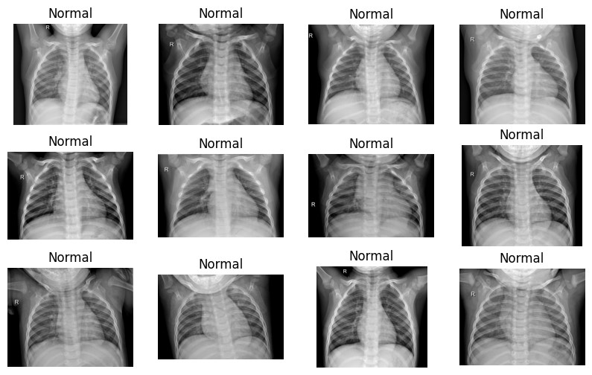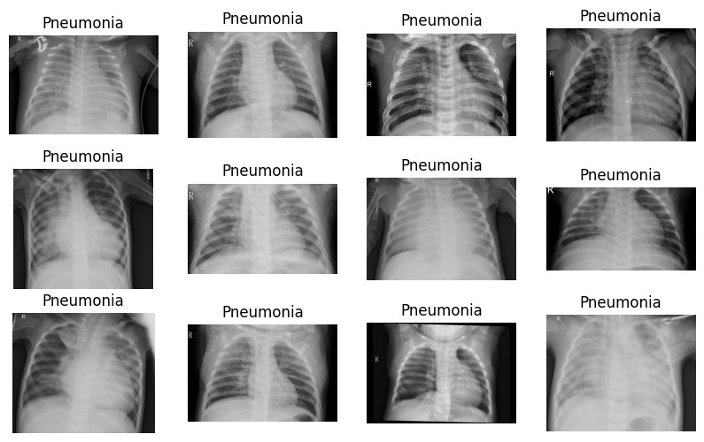

**Fig. 8. Normal Lungs** **Fig. 9. Lungs infected with Pneumonia**

On the other hand, the lung ranges in a pneumonia chest X-ray ”Fig. 2” picture continually show districts of obscurity or cementing. These areas, which may take after white or grayish shadows, are red hot lung tissue or alveoli (talk about sacs) that are fluid- or pus-filled. Pneumonia can appear in a grouping of ways depending on the basic cause, earnestness, and zone of the malady. It can impact one or both lungs. Crude or lobar opacities, talk about bronchograms (gloomy flying courses enveloped by opacities), and pleural radiations (fluid around the lungs) are common characteristics of pneumonia on chest X-rays.

B. Dataset description

The Chest X-ray pictures (Pneumonia) dataset is one of the preeminent predominant datasets on Kaggle for recognizing pneumonia. 10,326 chest X-ray pictures from this dataset are classified as conventional, bacterial pneumonia, or viral pneumonia. With 5,232 photos inside the planning set, 1,047 pictures inside the endorsement set, and 624 pictures inside the test set, the pictures are divided into three sets:  
  
planning, endorsement, and test. After making an account on Kaggle, the dataset can be downloaded. The COVID-19 Radiography Database is another Kaggle dataset that can be utilized to recognize pneumonia. Pictures from chest X-rays and CT looks of COVID-19 patients are included in this dataset, alongside pictures of people who have diverse respiratory conditions and sound lungs. The collection, which envelops a include up to of 13,975 photos, can be utilized to form classification models for pneumonia conclusion that depend on significant learning. The Montgomery Territory X-ray Set, which contains chest X-ray pictures with clarifications for tuberculosis and other lung contaminations, and the RSNA Pneumonia Area Challenge dataset, which contains chest X-ray pictures with comments for pneumonia, are two additional datasets that are open through Kaggle in development to these.[27]

**RESUITS:**

Below is a table representing all the metrics such as Accuracy, Precision, Recall as well as F1 scores.

|  |  |  |  |  |  |
| --- | --- | --- | --- | --- | --- |
| **S.no** | **Model** | **Accuracy** | **Precision** | **Recall** | **F1 Score** |
| **1.** | **ResNet50** | **0.6311** | **0.62957** | **1.0** | **0.77268** |
| **2.** | **InceptionV3** | **0.6535** | **0.64467** | **1.0** | **0.78395** |
| **3.** | **VGG16** | **0.7690** | **0.76562** | **0.9116** | **0.83227** |
| **4.** | **EfficientNetB0** | **0.62865** | **0.62865** | **1.0** | **0.77199** |

**Table**

After developing as well as evaluating all the models and their corresponding results through chest x ray dataset, we can clearly observe that Random Forest holds the top position in maintaining the most accurate levels at their level of performance. These estimations serve as essential rebellious for surveying the ampleness of machine learning models. Exactness reflects the model's for the most part rightness by comparing the number of change desires to the complete desires made. Precision especially assesses the accuracy of positive desires, illustrating the degree of precisely expected positive comes about among all events classified as positive. Audit, in addition called affectability, measures the model's capacity to recognize all critical cases by calculating the ratio of precisely expected positive events to the complete honest to goodness positive events. The F1 Score strikes a alter between precision and audit, giving a bound together degree that combines the qualities of both estimations. It ranges from to 1, where 1 illustrates a idealize alter between exactness and audit. Together, these estimations offer a comprehensive understanding of a model's prescient execution, empowering the comparison of particular machine learning calculations.

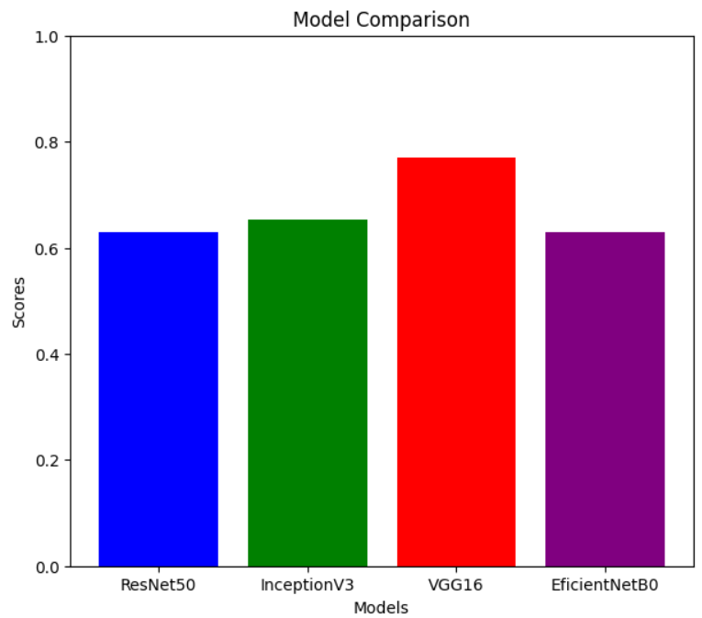

# **CONCLUSION**

In summary, the field of fundamental learning has appeared up up fundamental guarantee in recognizing pneumonia dependably from accommodating imaging information, such as chest X-rays, with befuddling exactness and specificity that are comparable to or without a address way better than that of human aces. Unmistakable considers around have sketched out out the ampleness of basic learning models in recognizing pneumonia and recognizing it from other sufferings, counting sound lungs, viral afflictions, or lung cancer.  
Assorted fundamental learning models, such as CheXNet, CheXNeXt, and others, have been proposed and endeavored for pneumonia classification, laying out exceptional comes almost in certification. It is fundamental to note, in any case, that basic learning models have their imprisonments. These models require a principal add up to of named information for organizing, and the quality of the organizing information sets a fundamental influence on their execution. Too, essential learning models may not ceaselessly be interpretable, which might compel their utilize in clinical decision-making.  
In appear up severely dislike toward of these detainments, essential learning holds colossal potential for progressing the categorization and conclusion of pneumonia. Be that since it may, offer offer assistance inquire around is required to address its controls and guarantee that it can be securely and sensibly executed in clinical settings.

**FUTURE SCOPE**

The combination of advanced machine learning and significant learning offers extraordinary potential to advance pneumonia assurance. Unsupervised strategies can lessen the require for large-scale labeled data. Combining routine picture planning gives more significant encounters, and consistent AI increases specialist certainty inside the system. Altering models to the broad and making helpful AI symptomatic devices appear revolutionize care, especially in resource-limited settings.

**REFERENCES**

[1] Rajpurkar, P., Irvin, J., Zhu, K., Yang, B., Xu, H., Wang, S., ... & Shlak, A. (2017). CheXNet: Radiologist-level pneumonia detection on chest X-rays with deep learning. arXiv preprint arXiv:1711.05225

[2] Lakhani, P., & Sundaram, B. (2017). Deep learning at chest radiography: automated classification of pulmonary tuberculosis by using convolutional neural networks. *Radiology*, *284*(2), 574-582.

[3] Anthimopoulos, M., Christodoulidis, S., Ebner, L., Christe, A., & Mougiakakou, S. (2016). Lung pattern classification for interstitial lung diseases using a deep convolutional neural network. *IEEE transactions on medical imaging*, *35*(5), 1207-1216.

[4] Zheng, S., Cornelissen, L. J., Cui, X., Jing, X., Veldhuis, R. N., Oudkerk, M., & van Ooijen, P. M. (2021). Deep convolutional neural networks for multiplanar lung nodule detection: Improvement in small nodule identification. *Medical physics*, *48*(2), 733-744.

[5] Ciompi, F., de Hoop, B., van Riel, S. J., Chung, K., Scholten, E. T., Oudkerk, M., ... & van Ginneken, B. (2015). Automatic classification of pulmonary peri-fissural nodules in computed tomography using an ensemble of 2D views and a convolutional neural network out-of-the-box. *Medical image analysis*, *26*(1), 195-202.

[6] Kundu, R., Das, R., Geem, Z. W., Han, G. T., & Sarkar, R. (2021). Pneumonia detection in chest X-ray images using an ensemble of deep learning models. *PloS one*, *16*(9), e0256630.

[7]Varshni, D., Thakral, K., Agarwal, L., Nijhawan, R., & Mittal, A. (2019, February). Pneumonia detection using CNN based feature extraction. In *2019 IEEE international conference on electrical, computer and communication technologies (ICECCT)* (pp. 1-7). IEEE.

[8] Rahman, T., Chowdhury, M. E., Khandakar, A., Islam, K. R., Islam, K. F., Mahbub, Z. B., ... & Kashem, S. (2020). Transfer learning with deep convolutional neural network (CNN) for pneumonia detection using chest X-ray. *Applied Sciences*, *10*(9), 3233.

[9] GM, H., Gourisaria, M. K., Rautaray, S. S., & Pandey, M. (2021). Pneumonia detection using CNN through chest X-ray. *Journal of Engineering Science and Technology (JESTEC)*, *16*(1), 861-876.

[10] Gupta, P. (2021). Pneumonia detection using convolutional neural networks. *Science and Technology*, *7*(01), 77-80.

[11] Sirish Kaushik, V., Nayyar, A., Kataria, G., & Jain, R. (2020). Pneumonia detection using convolutional neural networks (CNNs). In *Proceedings of First International Conference on Computing, Communications, and Cyber-Security (IC4S 2019)* (pp. 471-483). Springer Singapore.

[12] Račić, L., Popović, T., & Šandi, S. (2021, February). Pneumonia detection using deep learning based on convolutional neural network. In *2021 25th International Conference on Information Technology (IT)* (pp. 1-4). IEEE.

[13] Setiawan, W., & Damayanti, F. (2020, March). Layers modification of convolutional neural network for pneumonia detection. In *Journal of Physics: Conference Series* (Vol. 1477, No. 5, p. 052055). IOP Publishing.

[14] Rajpurkar, P., Irvin, J., Zhu, K., Yang, B., Mehta, H., Duan, T., ... & Ng, A. Y. (2017). Chexnet: Radiologist-level pneumonia detection on chest x-rays with deep learning. *arXiv preprint arXiv:1711.05225*.

[15] Militante, S. V., Dionisio, N. V., & Sibbaluca, B. G. (2020, October). Pneumonia and COVID-19 detection using convolutional neural networks. In *2020 Third International Conference on Vocational Education and Electrical Engineering (ICVEE)* (pp. 1-6). IEEE.

[16] Hashmi, M. F., Katiyar, S., Keskar, A. G., Bokde, N. D., & Geem, Z. W. (2020). Efficient pneumonia detection in chest xray images using deep transfer learning. *Diagnostics*, *10*(6), 417.

[17] Erdem, E., & AYDİN, T. (2021). Detection of Pneumonia with a Novel CNN-based Approach. *Sakarya University Journal of Computer and Information Sciences*, *4*(1), 26-34.

[18] Chouhan, V., Singh, S. K., Khamparia, A., Gupta, D., Tiwari, P., Moreira, C., ... & De Albuquerque, V. H. C. (2020). A novel transfer learning based approach for pneumonia detection in chest X-ray images. *Applied Sciences*, *10*(2), 559.

[19] Gao, T., & Wang, G. (2020). Chest X-ray image analysis and classification for COVID-19 pneumonia detection using Deep CNN. *medRxiv*, 2020-08.

[20] Zhang, D., Ren, F., Li, Y., Na, L., & Ma, Y. (2021). Pneumonia detection from chest X-ray images based on convolutional neural network. *Electronics*, *10*(13), 1512.

[21] Ko, H., Ha, H., Cho, H., Seo, K., & Lee, J. (2019, May). Pneumonia detection with weighted voting ensemble of CNN models. In *2019 2nd International Conference on Artificial Intelligence and Big Data (ICAIBD)* (pp. 306-310). IEEE.

[22] Tilve, A., Nayak, S., Vernekar, S., Turi, D., Shetgaonkar, P. R., & Aswale, S. (2020, February). Pneumonia detection using deep learning approaches. In *2020 international conference on emerging trends in information technology and engineering (ic-ETITE)* (pp. 1-8). IEEE.

[23] Moujahid, H., Cherradi, B., Gannour, O. E., Bahatti, L., Terrada, O., & Hamida, S. (2020). Convolutional neural network based classification of patients with pneumonia using X-ray lung images. *Advances in Science, Technology and Engineering Systems Journal*, *5*(5), 167-175.

[24] Saraiva, A. A., Ferreira, N. M. F., de Sousa, L. L., Costa, N. J. C., Sousa, J. V. M., Santos, D. B. S., ... & Soares, S. (2019, February). Classification of Images of Childhood Pneumonia using Convolutional Neural Networks. In *Bioimaging* (pp. 112-119).

[25] El Asnaoui, K., Chawki, Y., & Idri, A. (2021). Automated methods for detection and classification pneumonia based on x-ray images using deep learning. In *Artificial intelligence and blockchain for future cybersecurity applications* (pp. 257-284). Cham: Springer International Publishing.

[26] Yaseliani, M., Hamadani, A. Z., Maghsoodi, A. I., & Mosavi, A. (2022). Pneumonia detection proposing a hybrid deep convolutional neural network based on two parallel visual geometry group architectures and machine learning classifiers. *IEEE Access*, *10*, 62110-62128.

[27] <https://www.kaggle.com/datasets/paultimothymooney/chest-xray-pneumonia>

[28] <https://github.com/SAIKRISHNA239/Pneumonia_detection/blob/main/pneumonia.ipynb>